Fundraising Ideas While Practicing Social Spaciousness

Instagram or Facebook Item or Art Auction
How do I implement this?
- Obtain items or art that you want to auction and come up with a base price for everything you plan to auction
- Market on social media your auction and post rules for how it will run (Example in image below.)
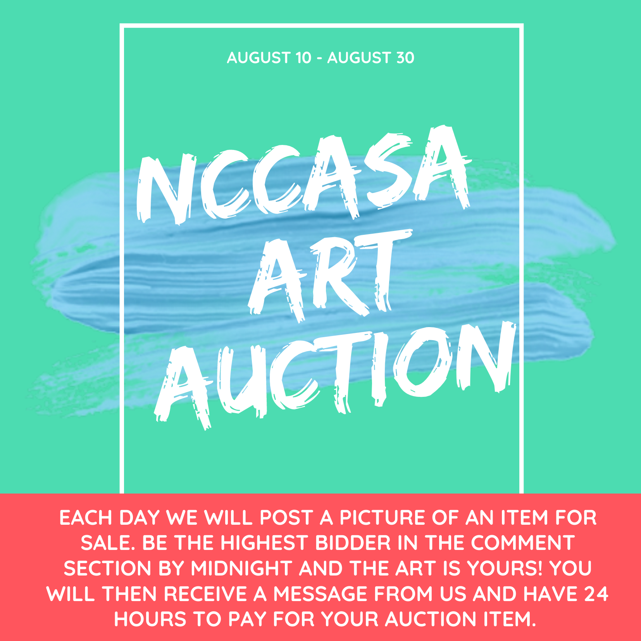
- Make sure you have a means for participants to pay you that is easily accessible, such as, venmo or paypal.
Drive-Thru Takeout Dinner for a Cause
How do I implement this?
- What are you cooking? You can make bbq and fixins or you can make a spaghetti dinner? The choice is yours! Which do you think your community will want more or which can you increase your funds with best?
- How much does it cost to buy, make, and sell versus how much will you price it?
- Market on social media and around the community what you’ll be selling and when this will take place (See image below for how this might look like.)
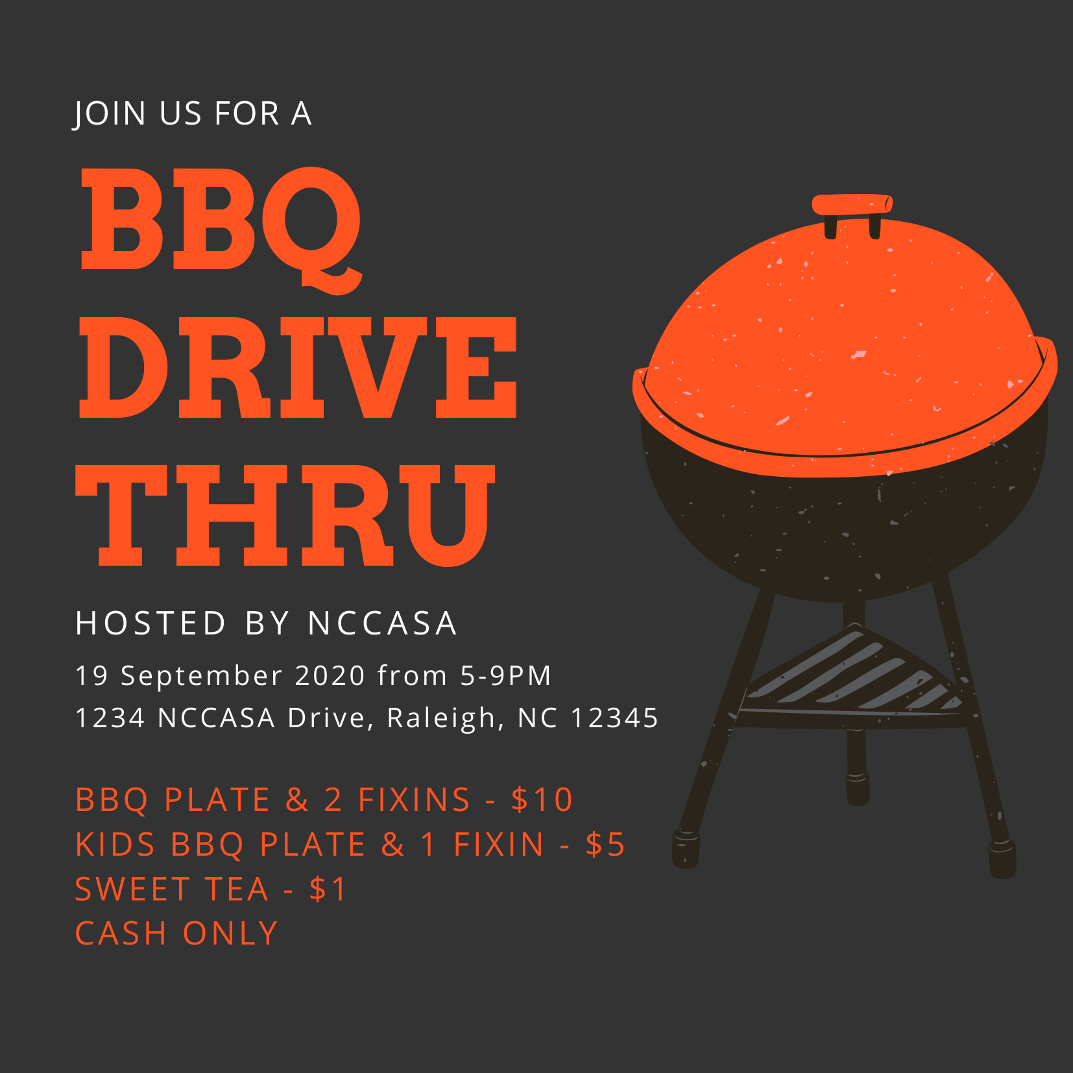
- To do this fundraiser safely while social distancing, follow the procedures that food pantries across North Carolina have implemented:
- All volunteers wear masks and gloves
- When cars pull up to your drive-thru, ask the driver to open the trunk of the car so you can put the food there - this allows for social distancing and the owner can drive to another location to then retrieve the food. You can also place food in the backseat if no one is there.

Live Stream Facebook Event
How do I implement this?
- Figure out what you will be discussing or doing in the video to engage your audience. This event could look like a Q&A and tour of what you do or anything else you think might engage your audience.
- Figure out when this will take place and market it on social media and your website
- You can use Facebook Live to connect with your audience and raise money at the same time by directing your audience to a link to your Donation Page or Crowdfunding page

Gala, But Make It Virtual
How do I implement this?
- Check out UnGala for how this peer-to-peer fundraising platform works
Cool idea that has been done with this app: virtual dinner party gala, dress up with your friends and enjoy some food and drinks at home for a good cause

Virtual 5k (or Bike-a-thon)
Though this one requires people to leave their house, it can still be implemented while promoting social spaciousness.
How do I implement this idea?
- Pick a day - time doesn’t necessarily matter because people can run outside whenever they choose to
- Set up a registration - set up a page on your website with a Google Form where people can register with their email, name, and any other information you want and include a PayPal link
- Confirm details - How do you want people to confirm that they did the 5k? Do you want them to post a picture under a hashtag and tag you or submit a picture to your email? Ex: #Virtual5kforSA @nccasa
- Advertise - get this information out there
- Email Runner Bibs - you can create this and send it out to anyone who is running so they can wear it the day of the run
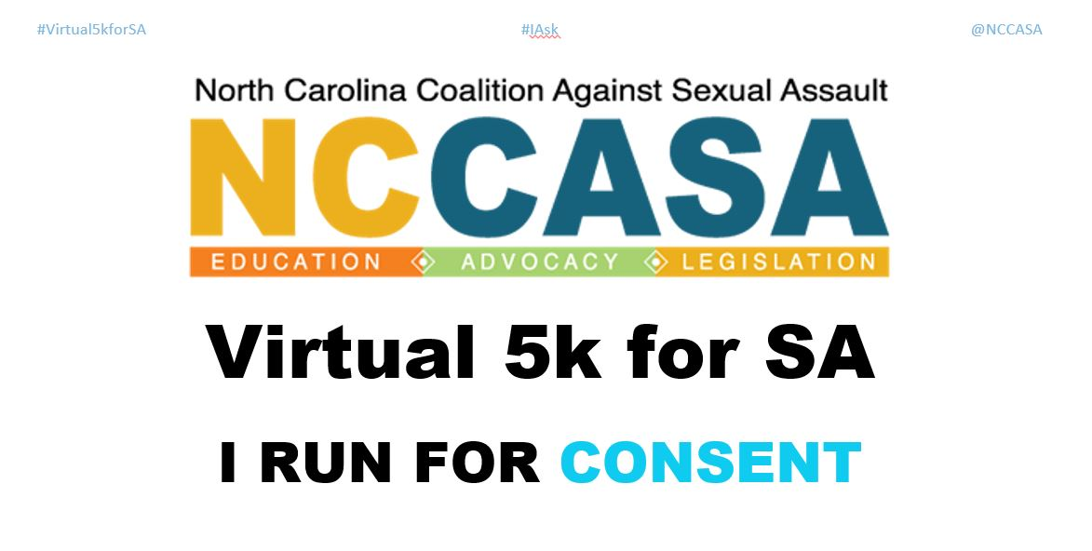
- Apps to Track Their Run - Have people track their run the day of by downloading apps like “Map my Run by Underarmour,” “Runkeeper,” or “Nike Run Club.”
- Day of Event - Have people take a picture with their runner bib or screenshot their run and post it under a hashtag you’ve created while tagging you. Make sure to repost what people share.
Want to skip most of the work above? Use RunSignUp to have people register, donate, and track their run.

Virtual Movie Night
How do I implement this?
- If we’re doing anything during this time, it’s watching a lot of movies. But this doesn’t have to be done alone! Host a Netflix Party!
- This site allows you to choose a movie and allow anyone to come and watch it with you. There are plenty of tv shows and movies related to consent, sexual violence, and other subjects related to this work. We recommend: To All the Boys I’ve Loved Before (consent) or Athlete A.
- In the comments section throughout the movie, provide links to your donation page or ask everyone to donate the price of a movie ticket at the beginning.
- This event can always be followed with a Facebook or Instagram Live Event where you discuss what happened in the movie or hold a Q&A - make sure to also link your donation page there.

