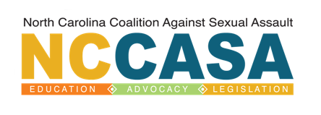

Rape Crisis Center and Organization Membership Application

Date:

Program/ Organization Name:

Street Address:

Mailing Address:

City: State: Zip Code:

Phone Number: - - Fax Number: - -

Name of Agency Executive Director:

Website:

Name of Primary Contact Person:

Title of Primary Contact Person:

Primary Contact’s Email Address:

Other Staff Email Addresses to Receive NCCASA Updates:

Please indicate which type of membership you are interested in:

Rape Crisis Programs & Organizations with budgets:
<$100,000 - $150/year $100,000-$500,000 - $300/year >$500,000 - $500/year

** Checks should be made payable to NCCASA.

Please return completed membership form with payment to:
NCCASA Member Services ∗ 811 Spring Forest Road, Suite 900 ∗ Raleigh, NC 27609

